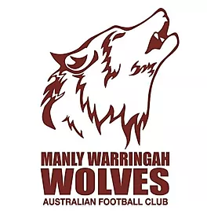

**AFL COMMUNITY CONCUSSION**

**GUIDELINES 2024**

There are a number of **important** changes to the Manly Warringah Wolves Concussion Management in 2024 (and ongoing) as per the AFL Community Concussion Guidelines (“Guidelines”).

Under the current Guidelines any player with concussion or suspected concussion must be:

1. Removed from playing/training and not return that day; and
2. Assessed by a Doctor (as arranged by the individual player) as soon as possible and within one to three days.

**Return To Play**

Progression through protocol to be managed by Club Physios (Square One) /Trainers.

|  |  |
| --- | --- |
| Stage 1. | Relative Rest (24-48hrs) |
| Stage 2. | Recovery  OK to continue to have symptoms  Can start exercising but NO team training drills M**in 6 days** |
| Stage 3. | Graded Loading  Must be symptom-free  Able to return to team training sessions  Progress from non-contact to limited contact to full contact M**in 14 days** |

Medical clearance is required from Doctor to return to Team training with **Full Contact.**

Once the above has been completed, and a player remains symptom-free, the player may return to play. **The minimum time to progress through this protocol is 21 days.**

**A player aged 18 or under** should be treated more conservatively and should be expected to take longer than 3 weeks to return to play.

Individual cases will have variable recovery times and may result in variable length of time to return to play.

Persistent symptoms will require ongoing medical care and management.